“JNANA SANGAMA”, BELAGAVI -590018.

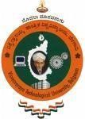

**An Internship Report on**

**“ORACLE APEX”**

**SUBMITTED IN PARTIAL FULFILMENT FOR THE AWARD OF THE DEGREE OF**

Bachelor of Engineering In

# COMPUTER SCIENCE AND ENGINEERING

Submitted By

A S HARINI (1JB21CS004)

Internship carried out at:

COGNIZANT TECHNOLOGY SOLUTIONS

**Under the guidance of**

**INTERNAL GUIDE**

**Mrs Shubha T V**

**Assistant Professor**

**Dept of CSE, SJBIT**

**EXTERNAL GUIDE**

**Grace Esther S**

**Jr. Executive - HR**

**CPO L&D GenC Training**

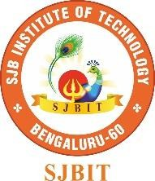

**DEPARTMENT OF COMPUTER SCIENCE AND ENGINEERING**

SJB INSTITUTE OF TECHNOLOGY

**An Autonomous Institute under VTU**

**#67, BGS HEALTH AND EDUCATION CITY, Dr Vishnuvardhan Road, Kengeri , Bengaluru-560060.**

**2024 - 2025**